Ex. No.: 5 Date:
Implementation and Simulation of Digital Logic Gates & Verifying Boolean Expression Using Truth Table

Aim:

Apparatus/Tool required:
ORCAD / PSpice simulator - > 7400 Library – 7432, 7408, 7404, 7400, 7402 & 7486
Source Library - Digclock
Simulation Settings: Analysis Type - Time Domain
Run to time: 2us (Logic Gates)
Run to time: 4us (Boolean Expression)
Circuit Diagram:

OR Gate Circuit

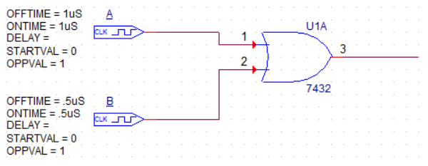

AND Gate Circuit

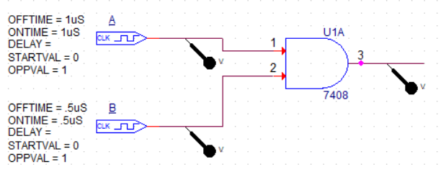

NOT Gate Circuit

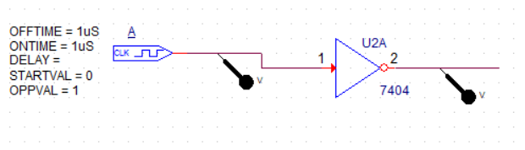

NAND Gate Circuit
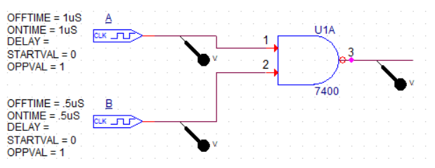

NOR Gate Circuit

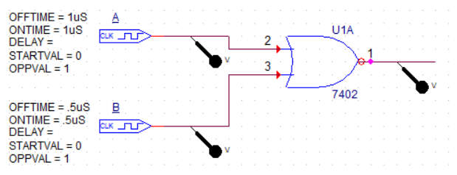

XOR Gate Circuit

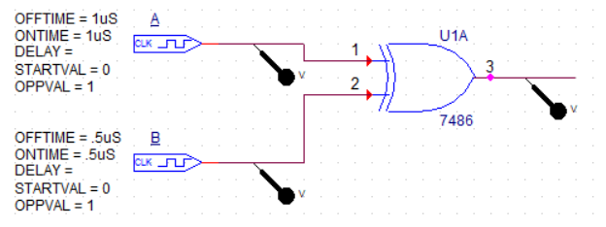

Write a Boolean expression for the output of the logic circuit. Also, give the truth table for the circuit

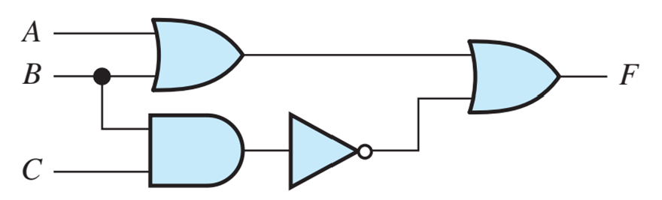

Theory:

OR Gate Circuit: Truth Table
A | B | Y
0 | 0
0 | 1
1 | 0
1 | 1

AND Gate Circuit: Truth Table
A | B | Y
0 | 0
0 | 1
1 | 0
1 | 1

NOT Gate Circuit: Truth Table
A | Y
0
1

NAND Gate Circuit: Truth Table
A | B | Y
0 | 0
0 | 1
1 | 0
1 | 1

NOR Gate Circuit: Truth Table
A | B | Y
0 | 0
0 | 1
1 | 0
1 | 1

XOR Gate Circuit: Truth Table
A | B | Y
0 | 0
0 | 1
1 | 0
1 | 1

Simulation Circuit Diagram and Output (Both Waveform and Truth Table):

AND Gate

OR Gate

NOT Gate

NAND Gate

NOR Gate

XOR Gate

Boolean expression of the Circuit
Procedure:

Result:

Inference:

Reg. No: Name: Date:

